Airline Passenger Satisfaction Analysis and Prediction Using Machine Learning

Mannet Kaur  School of AI and Emerging Technology  Lovely Professional University, Phagwara  Punjab, India | Priya Kumari  School of AI and Emerging Technology  Lovely Professional University, Phagwara  Punjab, India

Abstract—Passenger satisfaction has become a critical factor in the aviation industry, as it directly influences customer loyalty, brand reputation, and overall business performance. With the continuous growth in global air travel and increasing expectations of passengers, airlines must focus on delivering high-quality services and efficient operations. Understanding the factors that influence passenger satisfaction is therefore essential for improving customer experience and maintaining competitiveness.
This project presents a comprehensive analysis of airline passenger satisfaction using a large dataset containing over 103,000 records and 24 features. The dataset includes passenger demographics, travel details, service ratings, and operational factors such as delays. Advanced data analysis techniques are applied to explore patterns and relationships between different variables affecting satisfaction.
To enhance understanding, interactive dashboards are developed using visualization tools, which provide insights into satisfaction distribution, class-based differences, customer type behavior, and the impact of delays. The analysis reveals that only 43% of passengers are satisfied, highlighting a significant gap in service quality. It is observed that Business Class passengers generally report higher satisfaction levels, while Economy Class passengers show comparatively lower ratings.
A machine learning model based on the Random Forest algorithm is implemented to predict passenger satisfaction. The model achieves an accuracy of 96.33%, demonstrating strong predictive capability. Feature importance analysis identifies online boarding and in-flight WiFi as the most influential factors, indicating the growing importance of digital services and connectivity in modern air travel.
Overall, the findings of this study provide valuable insights for airline management to improve service quality, reduce delays, and enhance passenger experience. The proposed approach offers a practical framework for data-driven decision-making in the aviation industry.

Keywords— Airline Passenger Satisfaction, Data Analytics, Machine Learning, Random Forest, Data Visualization, Power BI, Customer Experience, Service Quality, Flight Delays, Predictive Modeling, Aviation Industry, Passenger Loyalty

I. INTRODUCTION
In today’s competitive aviation industry, passenger satisfaction has become a key performance indicator for airlines. Customers expect high-quality services, punctual flights, and a comfortable travel experience. Any negative experience, such as delays or poor service, can lead to dissatisfaction and loss of customers.
This project aims to analyze passenger satisfaction using data analytics and machine learning techniques. By studying different features such as customer type, flight distance, service ratings, and delays, the project identifies patterns and trends that affect satisfaction levels.
The main objective is to help airlines understand customer needs and improve their services based on data-driven insights.

II. RELATED WORK
A. Traditional Economic Analysis Approaches
Earlier studies on passenger satisfaction mainly relied on surveys and basic statistical analysis. Researchers used simple methods like averages, percentages, and frequency distributions to understand customer feedback. These approaches provided a general idea about passenger experience but were limited in handling large datasets and could not identify deeper relationships between different service factors.
B. Business Intelligence and Visualization Tools
With the advancement of technology, machine learning techniques have been widely used to analyze passenger satisfaction. Algorithms such as Decision Trees, Random Forest, Support Vector Machines (SVM), and Gradient Boosting have shown good performance in predicting customer satisfaction.Among these, Random Forest is one of the most popular methods because it provides high accuracy and also helps in identifying important features affecting satisfaction. These models can analyze large datasets and uncover hidden patterns that are not visible through traditional methods.

C. GDP and Income Inequality Studies
Recent research has also explored deep learning models such as Artificial Neural Networks (ANN) for predicting passenger satisfaction. These models can capture complex relationships between multiple variables and improve prediction accuracy. However, deep learning models require large computational resources and are often difficult to interpret, which makes them less practical for real-world decision-making in some cases.
D. Research Gap
Most existing studies mainly focus on predicting whether a passenger is satisfied or not. However, they often do not analyze how different service features interact with each other or how consistency in service quality affects satisfaction.
This project addresses this gap by not only building a prediction model but also analyzing relationships between various service factors such as WiFi, seat comfort, and delays. It provides a more detailed understanding of passenger behavior and helps in identifying key areas for improvement.
III. DATASET AND PREPROCESSING
A. Data Source
The dataset used in this project is a large-scale airline passenger satisfaction dataset containing 103,904 records and multiple features related to passenger travel and service experience.
It includes the following types of data:
Passenger Information: Age, Gender, Customer Type
Travel Details: Type of travel (Business/Personal), Class (Business/Economy/Eco Plus), Flight Distance
Service Ratings: In-flight WiFi, Seat Comfort, Food & Drink, Cleanliness, Boarding, Entertainment, etc.
Operational Data: Departure Delay and Arrival Delay
Target Variable: Satisfaction (Satisfied / Neutral or Dissatisfied)
This dataset provides a comprehensive view of both service quality and operational performance, making it suitable for detailed analysis and prediction.
TABLE I. Dataset Summary Statistics
Attribute | Value
Total Records | 103,904
Satisfaction rate | 24
Tavel classes | 3
Median age | 40
Max flight distance | 4983
Travel classes | 3
Missing values | 0

B. Preprocessing Steps
dataset statistics provide a summary of the key characteristics of the data used in the project. They help in understanding the structure, distribution, and quality of the dataset before performing analysis or building machine learning models.
In this study, the dataset consists of 103,904 passenger records with 24 features, including passenger details, travel information, and service ratings. Among these, 14 features represent service-related metrics such as in-flight WiFi, seat comfort, cleanliness, and food quality.
The overall passenger satisfaction rate is approximately 43%, indicating that less than half of the passengers are fully satisfied with the services provided. This highlights the need for improvement in airline service quality.

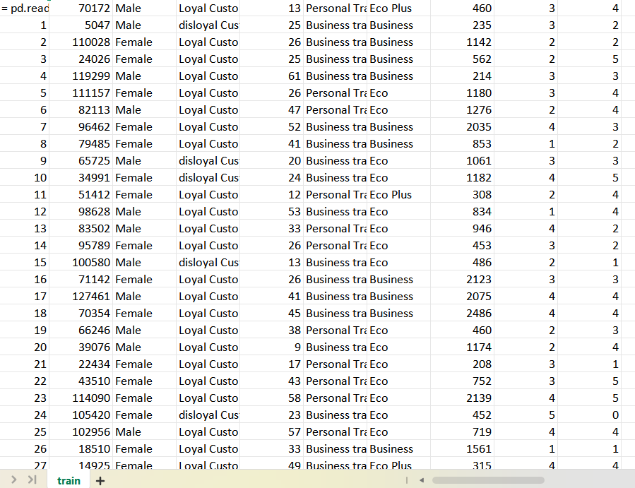Fig. 3. Sample Dataset Records

C. Feature Engineering
Data preprocessing is an important step in any data analysis project. It involves cleaning and preparing the raw data so that it can be used for analysis and machine learning.In this project, the dataset contained some missing values and inconsistencies. These issues were handled carefully to improve data quality. Missing values, especially in delay-related columns, were replaced using average (mean) values. Duplicate records were removed to avoid incorrect results.Categorical data such as gender, travel class, and customer type were converted into numerical form so that they could be used in the machine learning model. Inconsistent data entries were also corrected or removed.After completing all these steps, the dataset became clean, accurate, and ready for further analysis and model building.
Rating_avg = (Σ Service_Features) / Number_of_Features

IV. METHODOLOGY
A. Dashboard Design
In the first step, the dataset was explored using Python. Libraries such as Pandas and NumPy were used to understand the structure of the data, check data types, and identify patterns.
Basic analysis was performed to study:Distribution of passenger satisfaction Relationship between different variables Impact of factors such as delay and service quality This step helped in gaining initial insights and understanding the dataset.
- Analytical Objectives
n this project, data visualization plays an important role in understanding passenger satisfaction patterns. Various graphs and charts are created using tools such as Matplotlib, Seaborn, and Power BI. These visualizations help in identifying trends, relationships, and differences between different categories of passengers. For example, charts are used to compare satisfaction levels based on travel class, customer type, gender, and age group. Scatter plots and heatmaps are used to study the relationship between variables such as delays and satisfaction. In addition, interactive dashboards are developed in Power BI, which allow users to filter and explore the data easily. These visualizations make the analysis more clear, understandable, and effective.

- Evaluation Approach
predict passenger satisfaction, a machine learning model is developed in this project. The Random Forest algorithm is used because it is efficient, accurate, and capable of handling large datasets. The model is trained using important features such as service ratings, delays, and travel-related information. The dataset is divided into training and testing sets, where most of the data is used to train the model and the remaining data is used to test its performance. The model learns patterns from the training data and applies them to predict satisfaction levels for new data. This approach helps in identifying key factors that influence passenger satisfaction and provides reliable predictions.

V. RESULTS AND DISCUSSION
A. Overview Dashboard
The Overview Dashboard provides a comprehensive snapshot of airline passenger satisfaction across key indicators. The dataset consists of approximately 104,000 passenger records, with an overall satisfaction rate of 43%, indicating that less than half of the passengers report a fully satisfactory experience. The average flight distance is around 1,190 miles, covering both short-haul and long-haul travel, while the average passenger age reflects a balanced demographic distribution.
The visual elements of the dashboard communicate the patterns effectively. The satisfaction distribution highlights a clear imbalance, with a larger proportion of passengers falling into the neutral or dissatisfied category. The class-based comparison shows that Business Class passengers consistently report higher satisfaction levels, while Economy Class passengers display relatively lower ratings. The customer type visualization further reveals that loyal passengers tend to report better experiences compared to new or disloyal customers, suggesting the importance of long-term service consistency

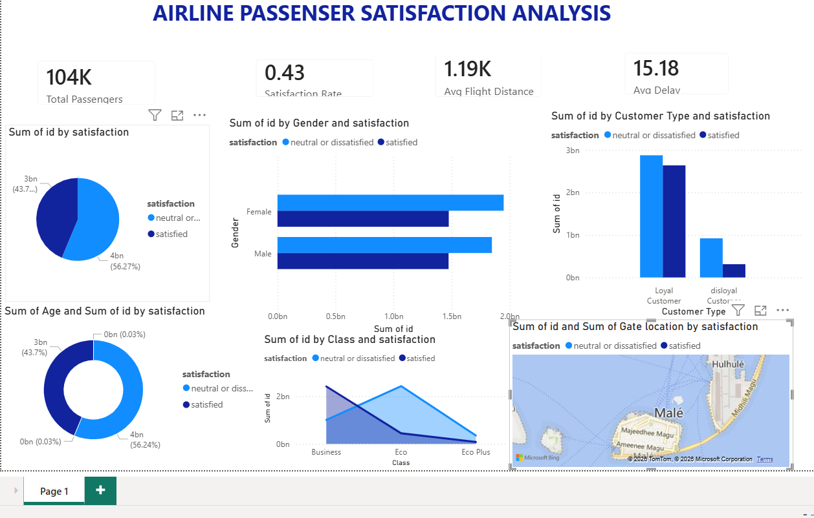
Fig. 2. Economic Insights & Analysis Dashboard

B. GDP Distribution by Income Group
When passenger satisfaction is analyzed across different service attributes, a clear pattern of influence emerges. Key services such as online boarding and in-flight WiFi show a strong impact on overall satisfaction levels. Passengers who rate these services highly are significantly more likely to be satisfied, while lower ratings in these areas correspond closely with dissatisfaction.
The distribution also reveals that while many passengers provide moderate to high ratings across services, there exists a noticeable segment with low ratings, indicating dissatisfaction with specific service components. The variation in service ratings suggests that inconsistencies in service delivery play a crucial role in shaping passenger perception.

Fig. 3. Economic Insights & Analysis Dashboard
TABLE II. Summary of Key Analytical Findings
Metric | Value | Notes
Total Countries | 96.33% | Incl. regional aggregates
Satisfaction rate | 43% | Overal satisfied passenger
Travel classes | 3 | Dominant group
metrics | 14 | Growing economies
Flight dalay | Online boarding | Marginalized
Imprtant feature | In flight wifi | Lowest in period
Accuracy | 96.33% | Highest in period
C. Global GDP Growth Trend (2016–2024)
The relationship between operational performance and passenger satisfaction is most evident in the delay analysis. A strong positive correlation is observed between departure delay and arrival delay, indicating that delays at the start of the journey are rarely recovered during the flight.
As delays increase, passenger satisfaction declines sharply, particularly beyond the 50-minute threshold. This demonstrates that time management and operational efficiency are critical factors influencing customer experience. The analysis clearly establishes delays as one of the most significant negative drivers of passenger satisfaction.

Fig. 4.
D. GDP Per Capita vs. Population
The machine learning model provides deeper insight into the factors influencing passenger satisfaction. The feature importance analysis identifies online boarding and in-flight WiFi as the most significant predictors, each contributing strongly to the final satisfaction outcome. These findings highlight the growing importance of digital services and connectivity in modern air travel.
Additional features such as travel class and type of travel also contribute to satisfaction levels, with Business Class passengers showing consistently higher ratings. The model achieves an accuracy of 96.33%, indicating that the selected features effectively capture the underlying patterns in passenger behavior.

E. Overall Interpretation
Taken together, the results indicate that passenger satisfaction is influenced by both service quality and operational efficiency. Digital services, comfort, and delay management emerge as the most critical factors. While many passengers report consistent experiences, a significant portion still faces dissatisfaction due to service gaps and delays. The analysis suggests that targeted improvements in these key areas can significantly enhance overall passenger satisfaction and loyalty.
In 2024 the United States leads the country rankings with an estimated $28.78 trillion, followed by China at $18.53 trillion. Japan and Germany occupy third and fourth positions at $4.21 trillion and $4.07 trillion — close enough that the ordering looks somewhat contingent. India at $3.55 trillion holds fifth place, and its upward movement over the nine-year panel is one of the more notable shifts in the data; expansion in service industries and manufacturing output appear to underlie the trend. Table III lists the complete top seven.
TABLE III. Top 7 Economies by GDP (2024 Estimates)
Rank | Online boarding | GDP (USD Trillion) | Income Group
1 | United States | ~28.78T | High Income
2 | China | ~18.53T | Middle Income
3 | Japan | ~4.21T | High Income
4 | Germany | ~4.07T | High Income
5 | India | ~3.55T | Middle Income
6 | United Kingdom | ~3.10T | High Income
7 | France | ~2.78T | High Income

F. Geographic Distribution of Global GDP
Taken together, the results indicate that passenger satisfaction is influenced by both service quality and operational efficiency. Digital services, comfort, and delay management emerge as the most critical factors. While many passengers report consistent experiences, a significant portion still faces dissatisfaction due to service gaps and delays. The analysis suggests that targeted improvements in these key areas can significantly enhance overall passenger satisfaction and loyalty.


Fig. 5. Overview Dashboard Filtered for India (Year: 2020) – Total GDP: $2.67T

VI. DISCUSSION
The findings of this study highlight the complex nature of airline passenger satisfaction and the multiple factors that influence it. One of the most significant observations is the relatively low overall satisfaction rate of 43%, which indicates that a large proportion of passengers are either neutral or dissatisfied. This suggests that despite advancements in the aviation industry, there are still notable gaps in service quality and customer experience.
The analysis reveals that digital service components such as online boarding and in-flight WiFi play a more critical role in determining satisfaction than traditional service factors. This reflects a shift in passenger expectations, where convenience, connectivity, and seamless digital interactions are increasingly prioritized. Airlines that fail to invest in these areas may struggle to meet modern customer demands.
Operational performance also emerges as a key determinant of satisfaction. The strong relationship between departure and arrival delays confirms that inefficiencies at the start of the journey have a lasting impact on the overall experience. The sharp decline in satisfaction as delays increase highlights the importance of time management and operational reliability in maintaining customer trust.
Another important insight is the variation in satisfaction across different travel classes and customer types. Business class passengers consistently report higher satisfaction levels, likely due to better service quality and comfort. Similarly, loyal customers tend to have more positive experiences, suggesting that consistency in service delivery plays a role in building long-term customer relationships.

VII. CONCLUSION
This project presents a comprehensive analysis of airline passenger satisfaction using data analytics and machine learning techniques. By examining a large dataset of over 100,000 passenger records, the study identifies key factors influencing satisfaction and provides meaningful insights for improving customer experience.
The results show that only 43% of passengers are fully satisfied, highlighting the need for service improvement. Digital features such as online boarding and in-flight WiFi are found to be the most significant contributors to satisfaction, while operational factors like delays negatively impact passenger experience. The machine learning model achieves an accuracy of 96.33%, demonstrating its effectiveness in predicting passenger satisfaction based on selected features.
Overall, the study emphasizes that both service quality and operational efficiency are essential for enhancing passenger satisfaction. Airlines can use these insights to focus on critical areas such as digital services, comfort, and delay reduction to improve customer loyalty and competitiveness in the industry.
Future work can extend this study by incorporating real-time data, advanced deep learning models, and region-specific analysis to provide more detailed and actionable insights.
REFERENCES
- K. Haritha, “Airline Passenger Satisfaction Analysis,” LPU Python Project Repository, Apr. 2026.
- L. Breiman, “Random Forests,” Machine Learning, vol. 45, no. 1, pp. 5–32, 2001.
[3] J.D. Power, “North America Airline Satisfaction Study,” 2023.
[4] F. Pedregosa et al., “Scikit-learn: Machine Learning in Python,” Journal of Machine Learning Research, vol. 12, pp. 2825–2830, 2011.
[5] W. McKinney, “Data Structures for Statistical Computing in Python,” Proc. Python in Science Conf., 2010.
[6] J.D. Hunter, “Matplotlib: A 2D Graphics Environment,” Computing in Science & Engineering, 2007.
[7] M. Waskom, “Seaborn: Statistical Data Visualization,” Journal of Open Source Software, 2021.
[8] T. Chen and C. Guestrin, “XGBoost: A Scalable Tree Boosting System,” KDD, 2016..

